**Team Name:** InSync

**Project Name:** Roombud

**Problem Title:** Students migrating for education looking to share a room or find roommates.

**Domain:** Education

**Problem Description:**

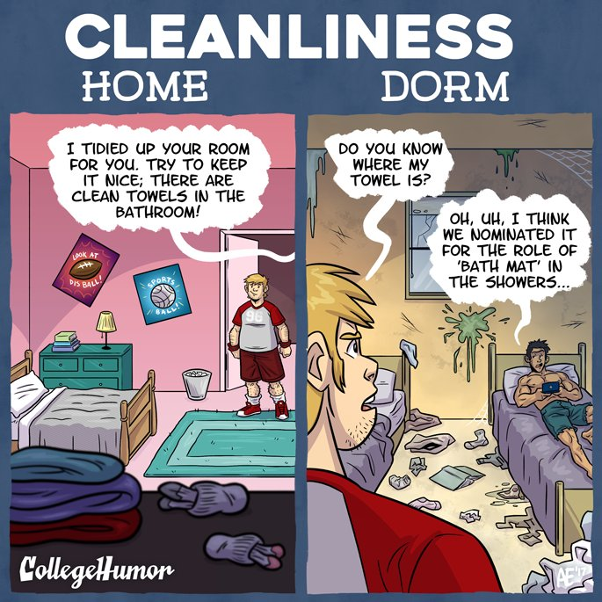The housing market is tough. Sky-high prices make it a challenge for young professionals to afford to buy or even renting on their own. Many students are turning to live with a roommate to help balance out the financial strain of rental prices. But living with someone else can either be an amazing experience or a pretty terrible one. We’ve all heard the horror stories of piles of dirty dishes, the garbage that’s never taken out and late-night weekday parties. You may have even experienced these frustrations first hand. Thankfully, with social networks and technology, it can be made easier to find accommodation for students as per their preferences.

**Solution:**

We propose a solution to find great places & like-minded roommates to make it possible to share your future room with the right roommates. It will allow the students to find the most appropriate match of room or roommates. Tenants will be able to post their accommodation details such as no of roommates, preferred/ existing roommates, availability duration, amenities and visuals.

Users will be suggested room or roommates nearest to their entered location based on factors such as availability, cost, duration, preferences (like a non-smoker, vegan, night owl, early bird, studious) and allow booking before-hand. It uses an algorithm based on unsupervised learning using clustering and dimensionality reduction paired with convolutional neural network performing predictive learning to match you up with a roommate that would best be suited for you. You answer questions about yourself, what you’re looking for in an ideal roommate and then its magic works to pair two matches together. It connects potential roommates using personality traits, keyword searches and interests to help you find your ideal match.

Once you find something that interests you, you’ll “like” your favorite places or potential roommates’ profiles, and if they “like” yours, you’ll be matched. Once you’re ready to message a potential “Roombud,” you can do so though the app so you don’t have to exchange any personal contact information until you’re ready. With so many roommate apps out there, it’s easier than ever to find a perfect roommate – or at least a good one. Gone are the days of blindly showing up at someone’s place or finding a classified ad in the paper.

**Technology Stack:**

Application - Flutter + Firebase

Backend - Cloud Firestore REST API + Flask (Microservice Architecture)

Database - Cloud Firestore (Cloud Database Service)

Match-Making - Unsupervised Learning + Dimensionality Reduction, CNN, Predictive Learning

Version Control - GitHub

Deployment Cloud – Heroku Cloud Platform

**Team Members:**

1.Sanchitsagar Singh

Gender - Male

Branch n Year- INFT BE

Contact No- 9869505118

Email - sanchitsingh0409@gmail.com

2. Akash Rajpurohit

Gender - Male

Branch n Year - INFT BE

Contact No - 9834551968

Email - akashrajpurohit.009@gmail.com

3. Raj Kotadia

Gender - Male

Branch n Year- INFT BE

Contact No - 8169659760

Email - rajkotadia15@gmail.com

|  |  |  |  |
| --- | --- | --- | --- |
| **Phase 0:** | **Task** | **Completion** | **Bugs** |
| **Hybrid App -** | | | |
|  | 1. Integrating Firebase |  |  |
|  | 2. OAuth 2.0 |  |  |
|  | 3. Preferences Selection |  |  |
|  | 4. Tenant (Opening) |  |  |
|  | 5. Roomie (Opening) |  |  |
|  | | | |
| **Match-Making -** | | | |
|  | 1. Data Modelling |  |  |
|  | 2. Traits Evaluation |  |  |
|  | 3. Model Training |  |  |
|  | | | |
| **Phase 1:** |  |  |  |
| **Hybrid App -** | | | |
|  | 1. Connecting To Firestore |  |  |
|  | 2. Tenant (Uploading Rooms) |  |  |
|  | 3. Roomie (Find A Roommate) |  |  |
|  | 4. Roomie (Discover) |  |  |
|  |  |  |  |
| **Match-Making -** | | | |
|  | 1. Evaluating Interest & Location |  |  |
|  | 2. Calculating Score Of Relationship |  |  |
|  | | | |
| **Phase 2:** |  |  |  |
| **Hybrid App -** | | | |
|  | 1. Roomie (Showing Room Results) |  |  |
|  | 2. Roomie (Showing Room Detail) |  |  |
|  | 3. Roomie (Finding Roommate) |  |  |
|  | 4. Collaborating Steps For Roommate |  |  |
|  | | | |
| **Match-Making -** | | | |
|  | 1. Predicting Final Match Results |  |  |
|  | 2. Connecting To Firestore |  |  |
|  | 3. Deploying Online |  |  |